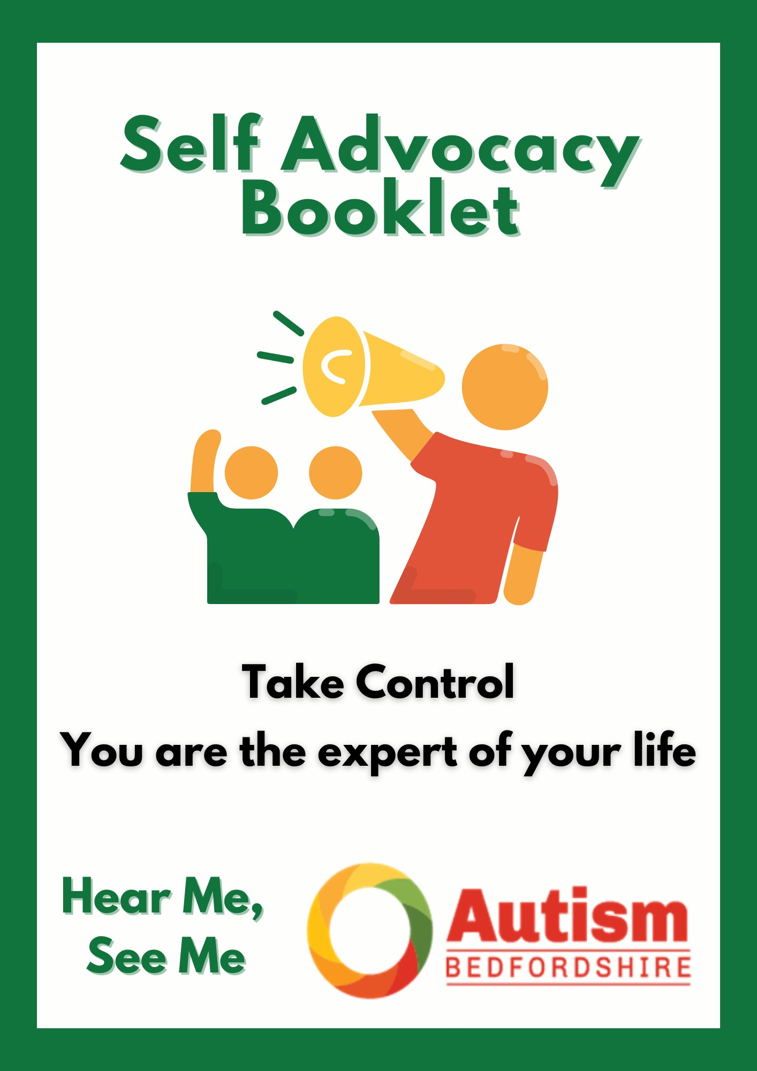
This booklet has been designed by members of the Hear Me, See Me Voice Groups across the East of England.

Sometimes due to being really anxious about a situation you may find it very difficult to talk to a professional about the issue you have gone to see them about.

We hope you can use this booklet which details a variety of situations to make notes of what you may need to say or ask for when you are finding it difficult to think or speak.

The information you write down in here may be useful for any situation you are in for example:
- within a healthcare setting,
- talking to your social worker
- talking to a plumber if you have a water leak
- getting ready for a meeting with your child’s teacher
- talking to your employer

We have designed it so that you can print out the page you need or you can print out the whole booklet.

If you have prepared questions to ask the professional, print them out and take them with you just in case you are too anxious to speak.

There are pages for you to write down your sensory differences so that you know what to ask for with regard to reasonable adjustments.

Reasonable adjustments
.
There are pages for you to write down your sensory differences so that you know what to ask for with regard to reasonable adjustments

What is a reasonable adjustment?

The Equality Act (2010) places a requirement on public services to anticipate and prevent discrimination against people with disabilities, which includes people with a learning disability, autism or both.
NHS England

Reasonable adjustments explained:

“Reasonable adjustments are changes that organisations and people providing services or public functions have to make for you if your disability puts you at a disadvantage compared with others who are not disabled.”
Hear Me, See Me Voice Group Attendee

“Establishments are asked to make reasonable adjustments to adapt to their disability such as putting up a wheelchair ramp or put all notices in braille, If they have a noise sensitivity then turn off any music playing and warn if the are going to be any imminent fire drills.”
Hear Me, See Me Voice Group Attendee

My Personal Information

Name: _________________________________

Address: _________________________________

_________________________________

Postcode: _______________________

Date of Birth: _______________________

Telephone: _______________________

Email address: ________________________________

How do you prefer to be contacted?
(Tick which you would prefer)

Text Phone Email

Other (describe how you want to be contacted)

In an Emergency

My preferred person to contact in case of an emergency:

Name: _________________________________

Address: _________________________________

_________________________________

Postcode: _______________________

Telephone: _______________________

If they cannot be reached this is my second
preferred person to contact in case of an emergency:

Name: _________________________________

Address: _________________________________

_________________________________

Postcode: _______________________

Telephone: _______________________

My support network (who helps me on a day to day basis)

Example: Name: Family Member
Contact Details: Address/Telephone
How do they help me: eg communicating with strangers,
how to socialise
Name:

Address:

Telephone:

Email:

How do they help me:

Name:

Address:

Telephone:

Email:

How do they help me:

Name:

Address:

Telephone:

Email:

How do they help me:

Name:

Address:

Telephone:

Email:

How do they help me:

Preparation beforehand

What do I need to do before going to see ….:
Example: Write list of questions to ask when I get there
Know what the appointment is about
How long is the appointment for
Do I need to book a double appointment – request extra time
Tell the professional how I prefer to communicate with them if I am not able to sit and talk with them
Do I need to take someone with me

What does the person I am going to see need to do before I see them:
Example: send the information about me before the meeting
Map sent out beforehand
Clear directions
Quiet sitting area
Make sure the lights aren’t too bright

What does the person I am going to do while I am with them:
Example: Doctors/Dentists/Hairdressers etc – need to tell you before they touch you what they are going to do
Give clear instructions
Be clear with questions and answers
Check the person has understood them as the question may need to be rephrased
Be honest
Do not be afraid to repeat questions
Give more of an explanation of what is going to be happening
Give information in written format as well as verbal so the information can be read again at home

What do I need to do to make the meeting/appointment more comfortable for me:
Example: What do I need to take (fidget toy)?
A notepad
Sunglasses

What do I need to do before phoning …. :
Example: Prepare text/questions before phoning
Prepare answer to leave on an answerphone
Re-negotiating the contract with suppliers, be succinct, speak clearly – ask for it in writing if you cannot understand what they are saying
Ask person to send information to you in writing after the call

What to do if I cannot handle making a phone call:
Example: Check the company website for a contact email
Use the ‘Live Chat’ feature
Ask companies to send a letter/email

There can be a difference between a live chat and a Bot – the robot will not understand what you are saying and may say hello again to you.
Sometimes the Bot will pass you over to a human or get a human to email you later.

Ask at the end of the phone call for the interaction to be followed up with a letter or email so you have the information in writing.

About Me

My Favourite Subject: Example: Cats, languages, motorbikes, films

Eye Contact: Example: I do not like to have to look at people’s eyes or have them
looking at me. When talking to me please do not look at me.

Anything else you would like others to know about you:

Sensory Differences:

Touch
Example: I hate to be touched/I don’t mind touch
Hospital Gowns will irritate me too much, I need to wear my own clothes
I cannot have the dentist putting their finger in my mouth

Hearing
Example: May find things too loud
May hear buzzing/ringing noises that others cannot hear
Ticking clock – may need clock removing while I am there
High pitched sounds

Taste:
Example: May find some food stuffs too spicy/salty and can only eat bland foods
Texture of some foods may be difficult to have in their mouth

Smell
Example: Some may have some comfort smells
Perfume and after-shave can be overpowering
Other strong smells too can be overwhelming

Sight
Example: Artificial lights can be too bright and overwhelming
I wear coloured lens glasses to help me with bright lights
Checking that obstacles are not left in the middle of the walkway
Dentists may have glasses which can help you while you are sat in the chair

Balance
Example: May need to use stairs as the lift can be hard to use

Movement
Example: May trip on steps/chair legs
May need to say if steps are up or down especially for non-sighted
Not having spatial awareness

Inner body feelings
Example: May not feel hunger or thirst – so may need reminding to eat or drink
May not feel the hot or cold – so may need to be told to put appropriate clothing on
May not feel pain

High Anxiety

If I am anxious you may see me:
Example: Sweat, need the toilet more often, stop talking and appear mute, go pale,
rock side to side, be over emotional (crying, angry)
If you see me starting to fidget this is a sign that I am starting to get anxious
Stop talking

If I am anxious this is how you can help me to calm down:
Example: Give me space – I don’t like people standing too close to me
Give me time – I may need more time to process what you are saying to me
If I have a favourite subject ask me to talk about it

If I am anxious this is how I can help myself to calm down:
Example: Get to a quiet space
Box breathing – in for four, hold for four and out for four
Sensory items – fidget toy, comforter, wrist bands to flick

Communication and Interaction Styles

How I will communicate with you –
Example: I prefer text or email rather than phone call
There could be a gap before I answer a question
It may take me time to reply
I may take notes to help me process it now and so I can read it and process it later

How you need to communicate with me -
Example: Give me time to process what you are saying
Don’t talk too fast
Check that I have understood what you have said, “Just to clarify what I said …..”
Saying the same thing but using slightly different words

Problems I could have with communicating ?
Example: Not being able to talk without being prompted
Talking continually
Easier to talk with people I have seen before
Butting in when people are talking
Needing more time to answer, even with a simple question
Avoid jargon and speak clearly

Problems I could have with interacting ?
Example: Approaching people at counters
Rushing me can make it take longer for me to process what I need to do
Sensory differences
Not expecting eye contact
It can be hard knowing when to talk and when to listen
Routines changing
If you turn up late to my appointment – can be distressing

Going to see a professional

What will help me:
Example: Appointments on time
Queuing – needing to leave the waiting room but not lose place
Telling me what is going to happen
Do not assume I know what will happen without you telling me
Fidget Toys
Be there at the appointed time
Do not change the time unless really necessary, the affect it has can be really distressing

Seeking work

What will help me:

The government has designed this leaflet to support a person who is seeking work and who may need reasonable adjustments. It will need filling in to identify areas where help or understanding is needed:
health-adjustment-passport.pdf (publishing.service.gov.uk)

Easy Read Version:
DWP health passport form Easy Read (publishing.service.gov.uk)

