Norfolk All Age Autism Strategy Refresh

Have your say to refresh the strategy.

The Norfolk Autism Partnership Board (NAPB) has put in place an Autism Strategy Reference Group to refresh the Norfolk All Age Autism Strategy. The NAPB works with autistic people, parents, carers and individuals working in healthcare, social care, education, voluntary organisations, the police and Healthwatch. To refresh the Norfolk All Age Autism Strategy the NAPB wants to hear the views of everyone.
We use identity first language (autistic people) as explained within the current Norfolk All Age Autism Strategy.
While Norfolk’s first All Age Autism Strategy resulted in improvements to support autistic people across Norfolk, much more needs to be done. We want to hear your voice about what is important to you and what needs to be done, to improve the lives of autistic people living in Norfolk.
Timeline of engagements to deliver the refreshed autism strategy:
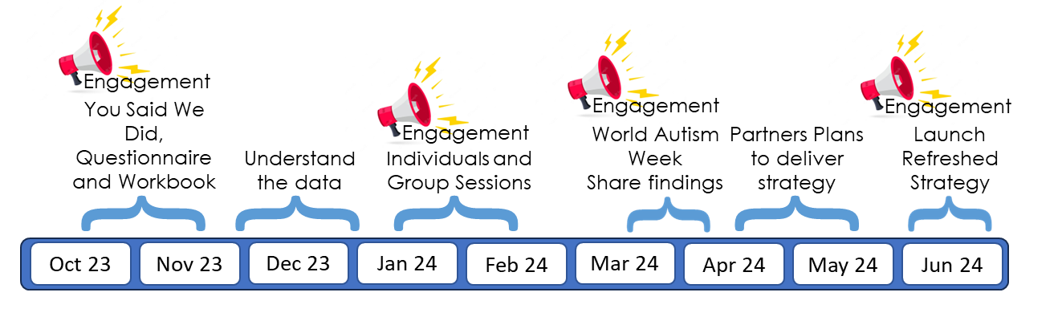
Before you complete this workbook, please read the You Said, We Did Summary, that details what partners plan to do to improve the lives of autistic people living in Norfolk. We will seek your views on this throughout.
This workbook will be available from Monday 16 October 2023 and will be available for three weeks with last responses accepted on Sunday 5 November 2023. The estimated time to complete the workbook varies between 15 to 30 minutes.
We will offer individual and group sessions during January and February 2024 to better understand what people have told us. If you would like to be involved in these sessions, please give us your details at the end of this workbook or complete the Autism Strategy Engagement form on the Norfolk Autism Partnership website.
We plan to deliver the refreshed strategy and a partnership plan in June 2024.

This workbook is separated into the following headings.
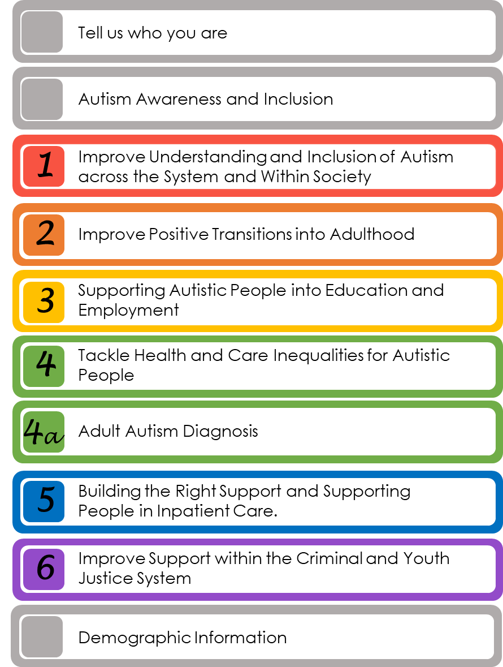

Only answer the questions that are important to you and skip any you do not want to answer.

THIS PAGE IS LEFT INTENTIONALLY BLANK

To ensure we gather the views of autistic people, parents and carers and professionals, it helps us to know who you are and how you heard about this workbook.

Tell us how you heard about this workbook to Refresh the Norfolk All Age Autism Strategy?

Through the Norfolk Autism Partnership.

Through an Autism Group or other Voluntary Sector Group

Through a Library

Through a school or education setting

Through Norfolk County Council or the NHS.

None of the above.

Please tell us more:

Thinking about who is completing the workbook, please tell us who you are?
If more than one option applies, please tick the first one that applies to you.

I am an autistic person aged under 18 years.

I am an autistic person aged 18 years plus.

I am a parent, partner, close family member, or carer of an autistic person.
A carer is someone who does not get paid for their caring role.

I am a professional working with autistic people.

A professional is someone who is paid to work with autistic people and can include personal assistants through direct payments.
I am none of the above.

Please tell us who you are:

If you are an autistic person, please tell us:
We want to support all autistic people regardless of where they are within their diagnostic journey.

I don’t have an autism diagnosis.

I am waiting for an autism diagnosis.

I have an autism diagnosis.

I prefer not to say.

THIS PAGE IS LEFT INTENTIONALLY BLANK

The following questions explore the current level of autism awareness and inclusion across Norfolk.
Are you aware of the work the Norfolk Autism Partnership or Norfolk Autism Partnership Board?

Yes

No

Unsure

Please tell us more about your level of awareness of the Norfolk Autism Partnership or the Norfolk Autism Partnership Board:

Are you aware of autism library sessions across Norfolk?

Yes

No

Unsure

Please tell us more about your awareness of autism library sessions across Norfolk:

Compared to 2019, when the first Norfolk All Age Autism Strategy started, do you feel autistic people (with or without a diagnosis) are more included within their communities?

Yes

No

Unsure

Please tell us more about why you answer Yes, No, or Unsure to the above question:

Do you want to tell us anything else about autism awareness or inclusion across Norfolk?

This priority focuses on improving the understanding and inclusion of autism among the public and professionals who work with autistic people, so that autistic people feel more included and less lonely and/or isolated.
At the end of this section, you will have the opportunity to explain in your own words what is important to you when thinking about the understanding and inclusion of autism.
Is this priority important to you?

No: go to Priority 2 on page 12

Yes: go to the question below

Are the plans listed below important to you?
The plans listed below are detailed as Priority 1 on the 'You Said, We Did' document under 'We Will: 2024 onwards'.
Tick all that apply:

An approach that provides autistic people, their families and carers with a voice and responds to their local needs and challenges.

Raise the awareness and inclusion of autism through social media and other activities.

Raise awareness of autism through autism resources made available to autistic people and their parents and carers.

Raise awareness of autism through autism awareness training that is coproduced and accredited by autistic people, available
to anyone and everyone.

Autistic people influencing the way services are designed, commissioned, and delivered to improve support.

Further develop autism library sessions, understand what is working well and replicate this across the county.

Organisations held to account to deliver the priorities within the refreshed strategy.

Is there anything else you would like to tell us about what is important to you that has not already been covered under Priority 1?
Please tell us more about this.

This priority focuses on supporting more autistic young people to live well in their community, and to find work or higher education opportunities.
At the end of this section, you will have the opportunity to explain in your own words what is important to you, when thinking about positive transitions into adulthood.
Is this priority important to you?

No: go to Priority 3 on page 14

Yes: go to the question below

Are the plans listed below important to you?
The plans listed below are detailed as Priority 2 on the 'You Said, We Did' document under 'We Will: 2024 onwards'.
Tick all that apply:

Through the Just One Norfolk website offer Special Educational Needs resources and training to parents and carers of autistic children.

Identify and connect autistic school leavers to Adult Learning and offer skills and employment support where appropriate.

Better support autistic children and young people within children’s residential homes who display behaviours of concern.

Is there anything else you would like to tell us about what is important to you that has not already been covered under Priority 2?
Please tell us more about this.

THIS PAGE IS LEFT INTENTIONALLY BLANK

This priority focuses on opportunities that enable autistic children, young people and adults to access the right support within education, volunteering and employment settings.
At the end of this section, you will have the opportunity to explain in your own words what is important to you, when thinking about education, volunteering and employment opportunities.
Is this priority important to you?

No: go to Priority 4 on page 16

Yes: go to the question below

Are the plans listed below important to you?
The plans listed below are detailed as Priority 3 on the 'You Said, We Did' document under 'We Will: 2024 onwards'.
Tick all that apply:

Make better links with school leavers and where appropriate, fast track support for autistic children and young people to
employment opportunities.

Identify and connect autistic adults to Adult Learning and offer skills and employment support where appropriate.

Offer autistic people more employment opportunities.

Improve health and social care support alongside alternative learning packages for those children who cannot attend
school.

Statutory providers to work in a more inclusive and accessible way, for example changing the language used for recruitment.

Strengthen the relationship between schools and the Norfolk Autism Partnership to develop positive representation of autism
throughout education.

Is there anything else you would like to tell us about what is important to you that has not already been covered under Priority 3?
Please tell us more about this.

This priority focuses on early identification and access to a timely autism diagnosis, and support to make sure that autistic people’s physical and mental health needs are met.
At the end of this section, you will have the opportunity to explain in your own words what is important to you, when thinking about tackling health and care inequalities for autistic people.
Is this priority important to you?

No: go to Adult Autism Diagnosis on page 18

Yes: go to the question below

Are the plans listed below important to you?
The plans listed below are detailed as Priority 4 on the 'You Said, We Did' document under 'We Will: 2024 onwards'.
Tick all that apply:

Improve access to a timely autism diagnosis through working with autistic people and others.

Improve the process for young people who are waiting for a neurodevelopmental diagnosis as they approach adulthood,
so that they receive a diagnosis in a timely way.

Offer tools and approaches to support autistic people to look after their wellbeing and access support available in their
community.

Promote the use of Mental Health in Autism tools that better identify suicidal thoughts and behaviours.

Coproduce autism specific social care assessment information, for staff to send to autistic adults before a social care
assessment.

Improve the availability of adult social care for autistic people through the Adult Social Care Workforce Strategy.

Provide guidance to autistic people on their right to choose where to receive treatment and how to access it.

Ensure providers who deliver services to autistic people are autism trained and put in place reasonable adjustments.

Put in place a reasonable adjustment auditing and evaluation system, to improve providers response to autistic people’s needs.

Identify the number of autistic people who have ARFID (Avoidant/Restrictive Food Intake Disorder) and look at how
support can be improved.

Develop a local suicide prevention strategy which considers the needs of autistic people.

Improve the reporting of deaths of someone with an autism diagnosis to the LeDeR programme (Learning from lives and
deaths – People with a learning disability and autistic people).

Is there anything else you would like to tell us about what is important to you that has not already been covered under Priority 4?
Please tell us more about this.

Norfolk County Council and the Norfolk and Waveney NHS Integrated Care Board wants to find out what is important to people when thinking about an adult autism assessment along with pre and post diagnostic support. They would like to improve the service identifying what support is needed before an assessment, how to access a diagnostic assessment and the support needed after an assessment.
At the end of this section, you will have the opportunity to explain in your own words what is important to you when thinking about how the service is offered.
Is this priority important to you?

No: go Priority 5 on page 22

Yes: go to the question below

What drives the need for an adult autism assessment? Tick all that apply:

Making sense of life experiences and providing validation.

Recognition that autism is an inherent part of a person’s identity.

Access to financial support.

Access to educational support.

Identification of need and support.

Something else?

Please tell us more:

If you suspect you may be autistic, would you seek an autism diagnosis? Tick all that apply:

Yes

No.

Unsure

Please tell us more:

What support do adults need prior to an autism assessment? Tick all that apply:

Understanding of reasonable adjustments that may help.

Access to an autism peer support group (where people use their own experiences to help each other).

Society’s acceptance of autism for those with and without an autism diagnosis.

Employment Support.

Educational Support.

Community events that embrace acceptance of autism.

Something else?

Please tell us more:

Which of these options would you find useful? Tick all that apply:

Ability to book your own appointment.

Find out online how long you are waiting for an assessment.

Complete online forms as part of the assessment process.

Offered an online assessment rather than face to face.

Offered a face-to-face assessment.

An online conversation with a professional.

A face-to-face conversation with a professional.

Online written guides about the assessment process.

Something else?

Please tell us more:

What support do you need after you received an autism diagnosis? tick all that apply:

Access to wellbeing support.

Peer Support Groups (where people use their own experiences to help each other).

Support to understand your diagnosis.

Support to meet your identified needs.

Understanding of reasonable adjustments that may help you.

Support to access community services that may help you.

Something else?

Please tell us more:

Is there anything else you would like to tell us about what is important to you that has not already been covered under this topic?
Please tell us more about this.

This section focuses on improvements to the provision and quality of community support to prevent autistic people from reaching crisis point and enable those in hospital to be discharged.
At the end of this section, you will have the opportunity to explain in your own words what is important to you, when thinking about building the right support in the community and supporting people in inpatient care.
Is this priority important to you?

No: go to Priority 6 on page 24

Yes: go to the question below

Are the plans listed below important to you?
The plans listed below are detailed as Priority 5 on the 'You Said, We Did' document under 'We Will: 2024 onwards'.
Tick all that apply:

Actively develop new adult supported living in places where people want to live.

Delivering an accommodation strategy to ensure that the right housing and support options are available for autistic people
over the next ten years.

Implement and evaluate the new Norfolk Autism Adult Support Service to improve and enhance support available.

Use the locally coproduced ethical framework developed by Curators of Change to commission and improve service
provision.

Look at current and future needs of autistic people to inform planning and delivery of health, wellbeing and social care
services in Norfolk.

Work to coproduce an adult autism directory, covering support available across Norfolk.

Improve the recording and reporting of autism across the system

Autism provider quality checks to ensure appropriate support and provision is provided for autistic people, including those with
learning disabilities.

Improve access to Mental Health services that are tailored to meet the needs of autistic people.

Identify the number of autistic people in inpatient beds and strengthen Care and Treatment Reviews, clarifying responsibilities
to ensure successful discharges from hospital.

Actively work with NHS England housing leads to consider all creative solutions to support autistic people with complex needs.

Is there anything else you would like to tell us about what is important to you that has not already been covered under Priority 5?
Please tell us more about this.

This section focuses on autistic people’s experience of coming into contact with the criminal and youth justice systems, ensuring that they have equal access to care and support where needed and that those who have been convicted of a crime can get additional support to engage fully in their sentence and rehabilitation.
At the end of this section, you will have the opportunity to explain in your own words what is important to you, when thinking about support within the criminal and youth justice system.
Is this priority important to you?

No: go to the next section on page 26

Yes: go to the question below

Are the plans listed below important to you?
The plans listed below are detailed as Priority 6 on the 'You Said, We Did' document under 'We Will: 2024 onwards'.
Tick all that apply:

Strengthen the voice of autistic people and their parents and carers who come into contact with the Criminal and Youth
Justice systems.

Ensure better access to support and reasonable adjustments through strengthening links between regional and local
forensic children and young people’s mental health services.

Scope how to better support assessments for autistic children and young people who are within the Criminal Youth Justice
System.

Scope activities to better support autistic children and young people through links between health services, police, Brave
Futures and the Norfolk Integrated Domestic Abuse Service.

Is there anything else you would like to tell us about what is important to you that has not already been covered under Priority 6?
Please tell us more about this.

THIS PAGE IS LEFT INTENTIONALLY BLANK

This section provides you with the space to share anything else that is important to autistic people that has not been covered already.

Is there anything else you would like to tell us about what is important to you that has not already been covered in the six priorities?
Please tell us more about this.

Thank you for completing this workbook. Your feedback will help us to identify the themes that are most important to autistic people.

Please hand this workbook back to the library, they will forward the workbook onto the Norfolk Autism Partnership Board.

What Happens Next?

We will offer individual and group sessions during January and February 2024 to better understand what people have told us.

If you would like to be involved in an individual or group session to tell us more about what is important to you, please give us your information here:

Name |  | Contact Number
Email Address

This page will be detached from your questions, to ensure we do not know who has provided the answers.
We will only use the details given to provide more information and an invitation to the individual and/or group sessions.

You do not have to provide your information here. If you wish to find out more about the group or individual sessions, information will be provided on the Norfolk Autism Partnership website.

Demographic information such as race, gender, sexual orientation, disability, and age will help us ensure we have reached out to a wide range of people. The section is optional. If you do not wish to provide any of your demographic information, please leave the section blank or select ‘Prefer not to say’.

How would you describe your gender? Tick one that applies:

Male

Female

Prefer not to say

None of the options above please detail:

Is your gender the same as your sex registered at birth? Tick one that applies:

Yes

No

Prefer not to say

How would you describe your sexual orientation? Tick one that applies:

Bisexual

Gay/Lesbian

Heterosexual/straight

Prefer not to say

None of the options above please detail:

What is your age group? Tick one that applies:

Under 16

16 to 17 years

18 to 24 years

25-34 years

35-44 years

45-54 years

55-64 years

Over 65 years

Prefer not to say

How would you describe your ethnic group? Tick one that applies:

Arab

Asian or Asian British

Black or Black British

Mixed or multiple

White

Prefer not to say

None of the options above please detail:

Do you have a long-term illness, disability or health problem that limits your daily activities or the work you can do? Tick one that applies:

Yes

No

Prefer not to say.

If yes, which of the following best describes your condition or disability? Tick all that applies:

Blind or partially sighted

D/deaf or hard of hearing

Limiting health condition e.g. heart disease, asthma, strokes, osteoarthritis, fibromyalgia and myalgic encephalomyelitis/
chronic fatigue syndrome (ME) etc

Learning disabilities

Neurodivergent conditions e.g. autism, attention deficit hyperactivity disorder (ADHD), dyslexia, dyspraxia

Mental health conditions e.g. depression, schizophrenia, bipolar affective disorder, eating disorders, obsessive compulsive
disorder

Physical disability e.g. limb disorder, amputee, wheelchair user, cerebral palsy, motor neurone disease, muscular dystrophy

Prefer not to say

None of the options above please detail:

What is your marital status? Tick one that applies:

Never married and never registered a civil partnership

Married

In a registered civil partnership

Separated, but still legally married

Divorced

Formally in a civil partnership which is now legally dissolved
Widowed

Surviving partner from a registered civil partnership

Prefer not to say

Who is (was) your legal marriage or registered civil partnership to? Tick one that applies:

Someone of the opposite sex

Someone of the same sex

Prefer not to say

What is your religion? Tick one that applies:

No religion

Christian (including Church of England, Catholic, Protestant and all other Christian denominations.

Buddhist

Hindu

Jewish

Muslim
Sikh

Prefer not to say

None of the options above please detail:

